Relevant web design styles

With our application being centred around clothing, looking at how popular clothing brands choose to style their sites could be a good source of inspiration on how we could style our web application.

Sites we have taken ‘stylistic’ inspiration from:

**Balenciaga:**

[*https://www.balenciaga.com/gb*](https://www.balenciaga.com/gb)

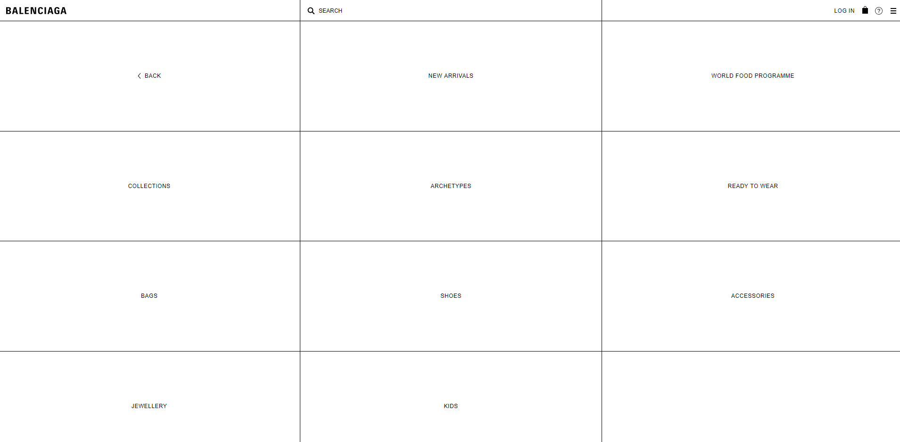

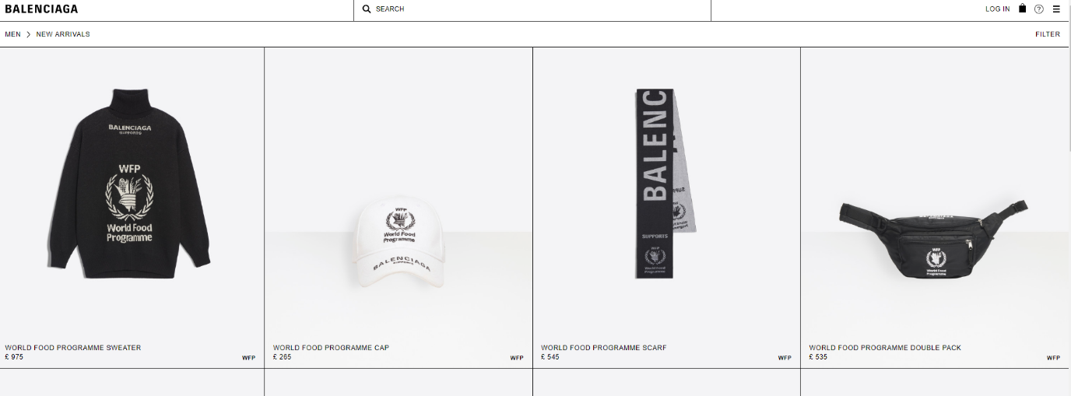

**Supreme:**

[*https://www.supremenewyork.com/shop/all*](https://www.supremenewyork.com/shop/all)

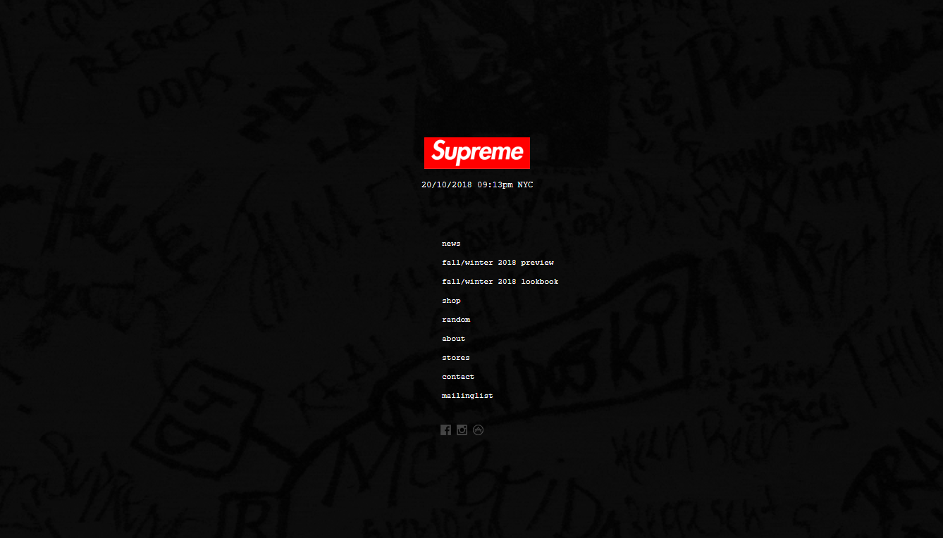

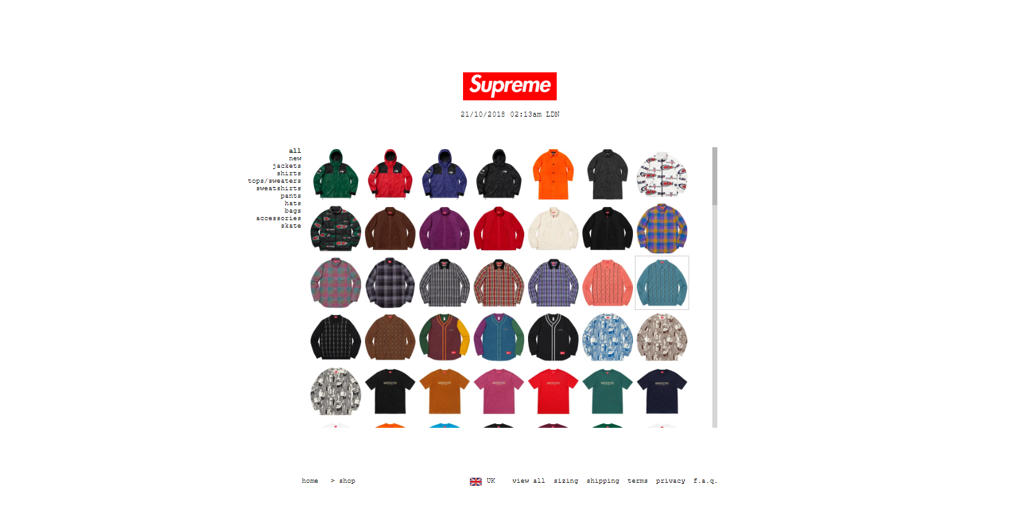

**OFF-WHITE:**

[*https://www.off---white.com/en/GB*](https://www.off---white.com/en/GB)

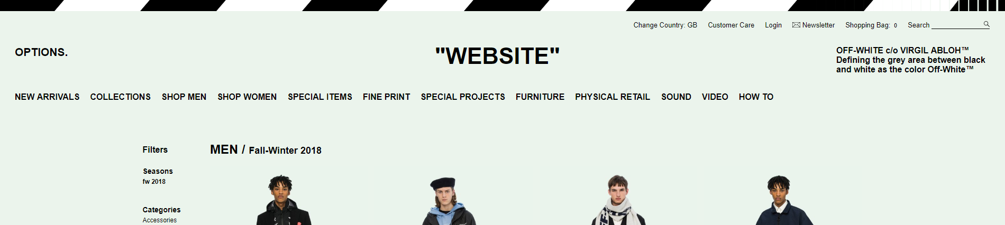

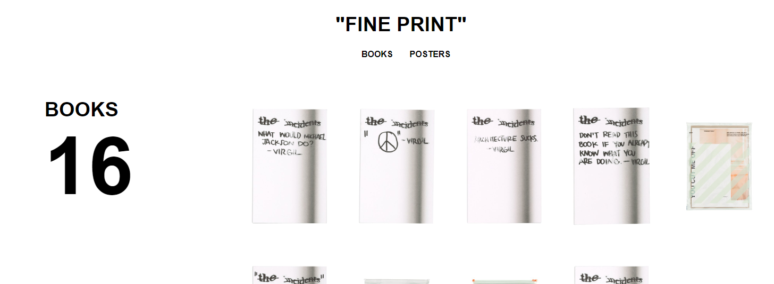

**GOLF:**

[*https://www.golfwang.com/*](https://www.golfwang.com/)

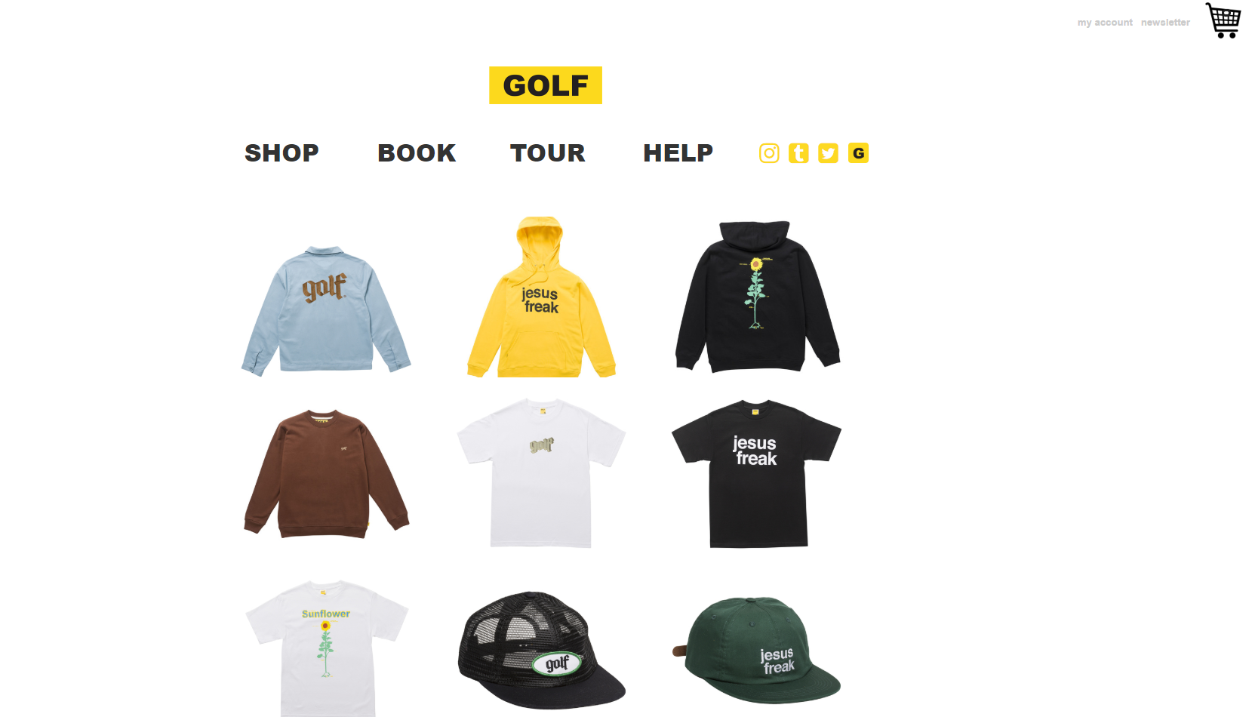

**FTP:**

[*https://fuckthepopulation.com/*](https://fuckthepopulation.com/)

